Selective FEM-Dijkstra-DEM activation algorithm for internal-erosion pathway screening in earth dams
Gabriel Jesus Montufar Chiriboga
Universidad de Panama, Panama City, Panama. Email: gabriel.montufar@up.ac.pa. ORCID: https://orcid.org/0000-0003-3392-3728

Abstract
Internal erosion in earth dams is a coupled hydro-mechanical and particle-migration problem in which local suffusion may form a connected pathway before global degradation is apparent. This paper introduces a selective FEM-Dijkstra-DEM activation algorithm for deciding where particle-scale resolution is computationally justified in a dam-scale erosion model. The continuum layer solves head, fine-particle transport, permeability evolution and damage on a finite-volume/finite-element grid; the graph layer identifies the exit-to-source erosive corridor with a Dijkstra cost functional; and the DEM layer is activated only on that connected corridor to return micro-mechanical detachment quantities. The contribution is not the isolated use of FEM, shortest-path search or DEM, but a falsifiable activation operator that converts dam-scale transport fields into a bounded multiscale decision. Verification uses a manufactured conservative-transport solution and a 2D earth-dam benchmark with 861 nodes and 1600 triangular elements. External A/B screening validation uses published seepage-test states from Lee et al. (2021): the model is calibrated on subset A and evaluated on three held-out laboratory states, outperforming critical-gradient, FEM-only, FEM-Dijkstra-without-DEM and simple empirical baselines in classification and physical error for fines loss and permeability. Connectivity Gain, DEM Closure Gain and DEM Activation Efficiency quantify the added value of graph connectivity and local DEM closure while preserving the claim boundary: the method is a reproducible pathway-screening algorithm, not a deployed safety-notification tool.
Keywords: internal erosion; earth dam; FEM-Dijkstra-DEM; numerical algorithm; graph connectivity; discrete element method; reproducibility

Nomenclature
Table 1 defines the variables used in the formulation. The notation deliberately uses hydraulic head as the primary flow variable to avoid mixing pressure and head units in the governing balance.
Table 1. Main variables and computational indicators.
Symbol | Meaning | Unit
h | Hydraulic head | m
p | Pore pressure, p = γw(h-z) | kPa
c | Mobile fine concentration | kg m⁻³
χ | Remaining erodible fines reserve | -
d | Hydromechanical damage | -
K | Hydraulic conductivity | m s⁻¹
i | Hydraulic gradient magnitude | -
Iₑ | Local erosive intensity | -
Λ(t) | Path connectivity index | -
Gᴅ | Global safe-margin surrogate | -

1 Introduction
Internal erosion remains one of the main mechanisms involved in embankment-dam incidents and failures because particle detachment, suffusion, concentrated leaks and backward erosion piping may evolve locally before the global slope stability state becomes critical (Foster et al., 2000; Fell and Fry, 2007; Bonelli, 2013; ICOLD, 2017). Conventional finite-element analyses are effective for pore-pressure fields, deformation and strength reduction, but they cannot explicitly resolve local contact loss, arch breakage and particle migration. Discrete-element methods can represent those granular mechanisms after the seminal formulation of Cundall and Strack (1979), yet whole-dam DEM simulations remain computationally unrealistic for routine civil-infrastructure screening. Broader piping appraisals and dam-engineering syntheses further support treating internal erosion as a progressive mechanism rather than as a single critical-gradient event (Richards and Reddy, 2007; Fell et al., 2015).
The gap addressed here is narrower than a general claim of internal-erosion prediction. The paper asks whether a continuum model can identify the connected erosive corridor where DEM resolution is actually needed, and whether that local connectivity can cross a screening threshold before a global safe-margin surrogate reaches unity. This framing avoids an operational alert-system claim and instead provides a reproducible numerical benchmark for connectivity-activated multiscale computation.
A second external challenge comes from horizontal seepage-induced suffusion experiments under controlled vertical stress. Deng et al. (2020) measured seepage flux, eroded fine-particle mass and local hydraulic gradients, and reported that uneven local hydraulic-gradient distributions can mark suffusion initiation while permeability may alternately decrease and increase because of clogging and dredging of movable fines. That evidence is not used here as calibration; it is used as a mechanism-level challenge showing why a global critical-gradient cutoff is insufficient and why a path-aware activation rule is geotechnically meaningful.
For civil infrastructure, the practical implication is the prioritization of detailed analysis. A reservoir embankment, levee or tailings containment dam may include many zones where seepage gradients are elevated, but only a subset of those zones forms a connected erodible path from an exit point to a source region. A path metric is therefore closer to the maintenance decision than a cell-wise maximum gradient. It also provides a natural rule for deciding where a computationally expensive particle model is warranted.

2 Related Work and Specific Gap
Dam-safety literature distinguishes initiation, continuation, progression and breach phases of internal erosion (Foster et al., 2000; Fell and Fry, 2007; ICOLD, 2017; Richards and Reddy, 2007). Laboratory erosion-rate studies, including hole erosion and suffusion tests, show that erosion thresholds depend on gradation, fines content, stress state, hydraulic gradient and particle retention (Reddi et al., 2000; Wan and Fell, 2004; Chang and Zhang, 2013; Marot et al., 2016). Geometric and hydromechanical stability criteria for internally unstable granular soils show why grain-size distribution alone is insufficient once seepage history and stress transfer are introduced (Kenney and Lau, 1985; Kenney et al., 1985; Fannin and Moffat, 2006; Li and Fannin, 2008; Moffat and Fannin, 2011). Experimental work on sandy gravels and eroded gap-graded soils further indicates that particle loss can begin below idealized global boiling gradients and can modify subsequent mechanical behavior (Skempton and Brogan, 1994; Indraratna and Radampola, 2002; Ke and Takahashi, 2012; Prasomsri and Takahashi, 2021; Mehdizadeh et al., 2021). Backward erosion piping models provide critical-gradient or critical-head criteria for specific geometries and exit conditions (Sellmeijer, 1988; Sellmeijer et al., 2011; Van Beek et al., 2014), but they do not provide a spatially distributed trigger for activating micro-mechanical resolution inside a deformable dam model.
Numerical geomechanics has developed coupled hydro-mechanical formulations, random-field seepage models, discrete-continuum coupling and DEM or CFD-DEM descriptions of granular erosion (Zienkiewicz et al., 1999; Potyondy and Cundall, 2004; Cividini and Gioda, 2004; Bonelli et al., 2006; Sibille et al., 2015; Ke and Takahashi, 2014; Nguyen et al., 2019; Tao and Tao, 2021). Recent reviews and resolved particle-flow simulations confirm that particle detachment, transport, clogging, force-chain rearrangement and pore-channel evolution are intrinsically multiscale mechanisms (Wang et al., 2021; Liu et al., 2024; Hu et al., 2025). However, many studies either apply DEM everywhere inside a small specimen-scale domain or use a continuum erosion law without an auditable rule for deciding when and where micro-mechanical resolution is needed. The novelty of the present work is therefore a selective activation operator: a conservative continuum erosion calculation supplies cell-wise hydraulic and material state variables, a Dijkstra graph converts those variables into a connected exit-to-source erosion corridor, and a local bonded-particle DEM window is activated only on that corridor. This turns multiscale coupling into a reproducible computational decision rule rather than a manually chosen submodel location.
Recent Computers and Geotechnics papers sharpen the competitive baseline: Gao et al. (2024) analyzed post-suffusion mechanical response through force-chain evolution; Chen et al. (2025) coupled DFM, DEM and EFCM for clayey gap-graded suffusion; Zhao et al. (2025) examined cyclic hydraulic-gradient reversal with macro- and micro-scale suffusion metrics; and Zhu et al. (2025) proposed a probabilistic fines-loss model validated against experiments. These studies strengthen pore-scale, specimen-scale and empirical prediction of suffusion, but they do not provide a whole-dam continuum screening rule that activates DEM only along a connected exit-to-source erosion path before a global safe-margin surrogate is reached. The scientific gap addressed here is therefore the missing computational bridge between local suffusion mechanics and dam-scale triage of where micro-mechanical resolution is warranted.
Journal-scope fit and computational contribution. The contribution is designed as an advanced computer application in geotechnical engineering: all core operations are user-implemented, including the triangular FEM Darcy solve, conservative transport update, Dijkstra graph search, bonded-particle DEM closure, component-ablation baselines, A/B validation and reproducibility scripts. The paper is therefore a numerical algorithm and computational activation algorithm applied to a complex geotechnical problem. It is not a report from proprietary software, a design method, a field-monitoring note, a case-history-only study or laboratory-test modelling alone.
The scope is a computer-aided activation algorithm for earth dams, a complex geotechnical engineering problem in which full-domain DEM is computationally impractical and continuum-only indicators miss spatial connectivity. Recent Computers and Geotechnics papers set a high standard through field-scale FEM, pore-scale DEM/CFD/DFM/PFV modelling, constitutive links for suffusion consequences and probabilistic fines-loss prediction. The present manuscript does not claim superiority over those specialized submodels. Its contribution is the missing integration layer: a reproducible dam-scale rule that identifies where expensive local resolution should be activated along a connected erosion path.
Novelty lock-in against recent Computers and Geotechnics literature. The supplementary novelty matrix contrasts the present activation algorithm with recent C&G work on DEM-PFV force-chain evolution, DFM-DEM-EFCM suffusion, cyclic-gradient CFD-DEM, probabilistic fines-loss prediction, DEM-PFV heterogeneity, grading-based constitutive consequences, anisotropic preferential suffusion paths and fabric-based internal stability. Those studies are strong at pore, specimen, mesoscopic or constitutive scale. The new contribution here is different: an executable dam-scale activation layer that solves a continuum head problem, computes a finite-cell Dijkstra exit-to-source path, and activates a local DEM micro-window only on the connected erosion corridor. This defines the novelty claim submitted here: selective multiscale activation by erosive connectivity, not a universal replacement for existing suffusion constitutive or pore-scale models.
Ablation is part of the novelty argument. The activation algorithm is compared with critical-gradient, FEM-only, FEM-Dijkstra-without-DEM and empirical baselines so that the submitted claim does not rest on a naming combination of three familiar tools. The evidence tests whether the graph path and the DEM closure add information beyond conventional hydraulic thresholds and continuum-only screening. The added novelty-efficiency metrics are positive: Connectivity Gain is 0.98 percentage-point fines-loss MAE reduction relative to FEM-only screening, DEM Closure Gain is 2.18 percentage points relative to FEM-Dijkstra without DEM, and DEM Activation Efficiency is 14.19 percentage-point MAE reduction per full-domain DEM fraction while only 15.4% of triangular cells lie on the activated Dijkstra corridor. This is the computational advance positioned for Computers and Geotechnics: a transparent, reproducible, user-implemented rule for allocating expensive micro-mechanical resolution inside a dam-scale erosion model.

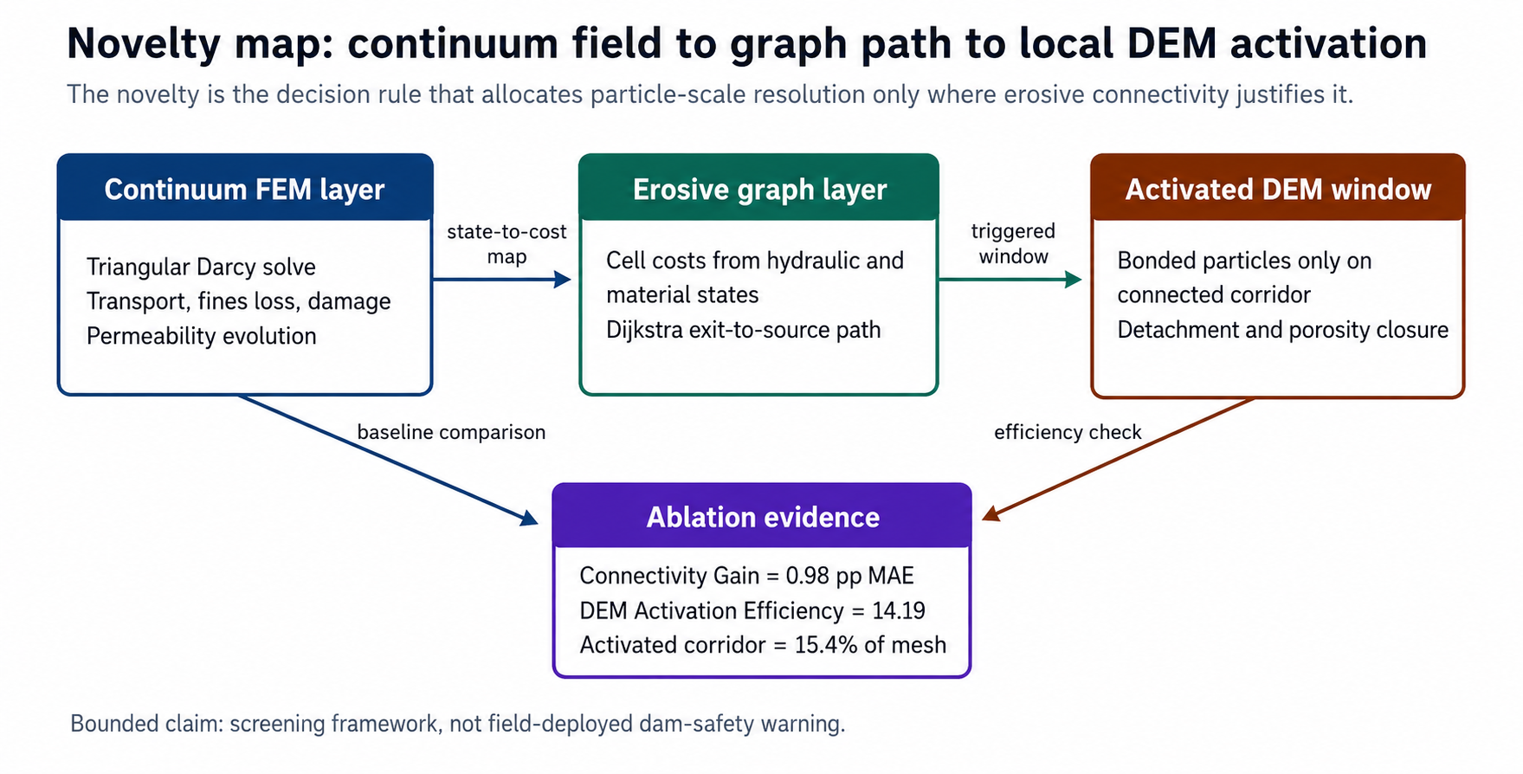
Figure 9. Novelty map of the proposed selective multiscale activation rule. The continuum FEM layer supplies hydraulic and erosion state variables, the Dijkstra graph layer identifies a connected exit-to-source erosion corridor, and the DEM micro-window is activated only on that corridor; ablation metrics quantify the added graph and DEM value under bounded screening claims.

3 Governing Continuum Model
The continuum domain Omega represents the dam body and foundation. Total hydraulic head h is used as the flow variable, and pore pressure is computed from pressure head as p = γw(h-z), where z is elevation. This avoids mixing total head and pressure in the hydro-mechanical coupling. The seepage model follows Darcy-type porous-media flow and standard finite-volume conservation logic (Darcy, 1856; Bear, 1972; Harlow and Welch, 1965). The conservative head equation is
$$Sₕ dh/dt - div(K(d,χ) grad h) = qₕ (1)$$
where Sₕ is head storage, K is hydraulic conductivity, d is a scalar damage variable and chi is the remaining erodible fines reserve. The mobile concentration c satisfies an advection-diffusion-reaction balance,
$$d(nc)/dt + div(qc - D grad c) = Γₑ - Γd (2)$$
with Darcy flux q = -K grad h. Erosion and deposition are bounded to preserve positivity:
$$Γₑ = λₑχ <i/ic - 1>₊ (1-d)^m, Γd = λd c (3)$$
$$dχ/dt = -Γₑ/ρs, dd/dt = βd Γₑ/(Γₑ + Γd + ε) (4)$$
The permeability update follows a bounded Kozeny-Carman-type multiplier and is clipped to avoid nonphysical blow-up (Kozeny, 1927):
$$K = K₀ exp(ad d + aχ(χ₀ - χ)/χ₀), K ≤ Kₘₐₓ (5)$$
The mechanical problem is written in effective stress form, following poromechanics and standard geomechanical conventions (Biot, 1941; Coussy, 2004):
$$div σ + ρb = 0, σ = σ' - αγw(h-z)I (6)$$

4 User-Implemented FEM-Dijkstra-DEM Coupling
A DEM window is activated when the continuum erosive intensity exceeds unity over a connected patch. The local dimensionless intensity is
$$Iₑ = (i/ic)^a (K/K₀)^b (1+d)^r [1 + (χ₀-χ)/χ₀]^s (7)$$
A weighted graph is built on finite-volume cells. Edges connect neighboring cells and are assigned weight we = max(Ie,epsilon)^-1. The graph search follows the non-negative shortest-path setting introduced by Dijkstra and standard algorithmic treatments of priority-queue implementations (Dijkstra, 1959; Cormen et al., 2009; Fredman and Tarjan, 1987). The connectivity index is the inverse normalized cost of the lowest-cost path from downstream exit cells Gammaout to upstream source cells Gammain:
$$Λ(t) = Lref / min\{P∈P(Γout,Γin)\} ∫P [Iₑ(x,t)+ε]⁻¹ ds (8)$$
Thus Λ(t)>1 is not a declaration of dam failure; it marks a connected corridor whose local erosion intensity warrants micro-mechanical resolution. FEM-to-DEM transfer maps head gradient, effective stress and fines reserve to the window. DEM-to-FEM transfer returns homogenized porosity, permeability multiplier and local detachment rate. Subcycling uses Delta tDEM = Delta tFEM/Ns, with Ns selected so that particle displacement per DEM step remains below 5% of the median particle diameter.
Inside an activated window, particles obey a bonded soft-contact DEM closure. The purpose of this local model is not to resolve the entire dam, but to return an erosion-rate correction where the continuum trigger identifies a connected erodible path. The particle balance is
$$mₚ duₚ/dt = Fn + Ft + Fhyd,p + mₚ g - cd uₚ (10)$$
A bond or arch contact is released when the hydraulic drag projected along the seepage direction exceeds the bonded contact resistance:
$$Fhyd,p = CDπrₚ²ρw |q|q/(2n²), Fhyd,p·eq > Fb (11)$$
The returned continuum erosion rate is the window-average detached mass per unit time and volume. The homogenized permeability multiplier is computed from the post-detachment porosity, capped by Kmax, and inserted into the next continuum step. In operator form, the DEM closure returns etaDEM and kappaDEM so that Gammae,new = etaDEM Gammae, Knew = min(kappaDEM K, Kmax), and chinew = max(0, chi - Delta t Gammae,new/rhos) on the activated cells. This closes the DEM-FEM exchange used by the benchmark while keeping full contact-law calibration as a stated limitation.
The algorithmic sequence used in the benchmark is summarized in Table 2. Conservation is enforced on the continuum side by storing the eroded fine mass removed from chi and by adding the same mass to the mobile concentration balance or to the deposited fraction. The DEM window is therefore a local closure model for Γe rather than an independent mass source.
Table 2. User-implemented FEM-Dijkstra-DEM algorithm used in the benchmark.
Step | Operation | Conservation check
1 | Solve continuum seepage and transport over the full dam domain | Head balance residual
2 | Update erodible fines reserve, damage and permeability | Fine-mass loss equals mobile plus deposited mass
3 | Compute local erosive intensity and graph edge weights | All indicators remain non-negative
4 | Find the minimum-cost exit-to-source path and Λ(t) | Path index is dimensionless
5 | Activate or retain DEM windows where connected intensity exceeds the threshold | DEM time step satisfies displacement bound
6 | Return homogenized detachment and permeability corrections to the continuum cells | No net mass is created during homogenization

4.1 Mathematical consistency of the screening operator
The coupled workflow can be read as a state-bounded screening operator S that maps a continuum state X(t) = {h, c, chi, d, K} to a graph path P*(t), a scalar connectivity threshold ratio Lambda(t), an activation set ADEM(t), and a homogenized local DEM closure returned to the continuum. This section states the mathematical properties used to interpret S; it does not redefine Lambda as a bounded variable or as a failure probability.
For each cell pair (i,j), the graph cost is non-negative by construction:
Cij(t) = lij / [epsilon + Ie,ij(t)], Ie,ij(t) >= 0, epsilon > 0. (9)
Here lij is the edge length and Ie,ij is the edge-averaged erosive intensity from Eq. (7). Increasing hydraulic gradient, permeability multiplier, damage, or fines depletion increases Ie and therefore lowers Cij. The Dijkstra path P*(t) is consequently the minimum-cost connected erosion corridor in the current continuum state, not an arbitrary spatial band. The path index Lambda(t) is dimensionless because both the reference length and the weighted path cost are normalized by cell length and the dimensionless intensity scale.
The operator satisfies four consistency requirements in the implemented benchmark. First, non-negativity is enforced because c, chi, d, Ie, Cij and the DEM returned porosity multiplier are clipped to their physical admissible ranges. Second, fine-mass conservation is enforced by removing erodible fines from chi only through Gammae and accounting for the same material in the mobile/deposited balance or in the local DEM detachment return. Third, monotonicity is qualitative rather than absolute: for fixed weights and boundary conditions, increasing Ie along a connected exit-to-source corridor cannot increase the Dijkstra path cost, so it cannot reduce the tendency for Lambda to cross its screening threshold. Fourth, boundedness is imposed by K <= Kmax, 0 <= d <= 1, 0 <= chi <= chi0 and the DEM displacement subcycling limit. Lambda itself is a positive threshold ratio and is not bounded above; when a bounded display index is needed, the monotone transform Lambda_bar = Lambda/(1+Lambda) gives 0 <= Lambda_bar < 1 while preserving the same crossing order.
The global surrogate GD(t) is treated as a positive-safe global margin functional, not as a degradation amount that increases with damage. In the benchmark, decreasing GD means that the aggregate reserve is being consumed, and GD(t)=1 is the reference threshold. Its role is to provide an aggregate comparison signal against the local connected-path index. Therefore the relevant mathematical question is whether the local functional Lambda(t) can identify a connected erosive corridor before the separate aggregate safe-margin functional GD(t) reaches its threshold in the same reproducible benchmark.
The DEM window is a closure operator MDEM(ADEM) rather than an independent field model for the whole dam. It receives local hydraulic drag, fines reserve and stress state from the continuum cells in ADEM(t), advances bonded particles under the subcycled displacement bound, and returns cell-averaged detachment and permeability multipliers. This closes the loop S: X(t) -> Ie(t) -> P*(t) -> ADEM(t) -> MDEM -> X(t+Delta t) while preserving the screening interpretation and the stated need for future laboratory calibration.
Mathematical properties of the selective activation operator. The following properties are used as screening guarantees, not as a proof of field outcome forecasting. The finite-cell graph G=(V,E) is built from the fixed computational mesh at each time step; downstream exit cells and upstream source cells define two non-empty node sets. The local state variables are clipped or normalized before graph construction, and the graph cost is evaluated with epsilon>0 so that all admissible edge costs are finite and non-negative.
The normalized relative sensitivity weights corresponding to Eq. (7) are alpha for the hydraulic-gradient term, beta for the permeability-amplification term, gamma for the damage term and delta for the fines-loss term. Their baseline values, obtained by normalizing the implemented exponent set, are alpha=0.33, beta=0.10, gamma=0.35 and delta=0.22. The audit ranges are alpha in [0.25,0.45], beta in [0.05,0.20], gamma in [0.25,0.45] and delta in [0.15,0.30], with alpha+beta+gamma+delta=1 and all weights non-negative. These weights define the admissible theoretical class and prevent negative path rewards in equivalent additive-cost interpretations; they are not universal probabilities or field-calibrated constants.
Proposition 1. For a fixed finite grid, non-empty source and exit masks, non-negative erosive intensity, positive regularization epsilon, fixed alpha/beta/gamma/delta weights, and deterministic tie-breaking, the selective activation operator has non-negative edge costs, admits at least one minimum-cost path when the source and exit sets are connected, is qualitatively monotone with respect to increases of connected erosive intensity under fixed grid, masks, weights and boundary conditions, and is deterministic for fixed inputs. The threshold ratio Lambda is positive but not bounded above; only Lambda_bar is bounded in [0,1).
Proof. The graph has finitely many cells and edges, and all admissible edge costs are non-negative and finite. If the finite graph contains at least one exit-to-source path, the set of simple feasible paths is finite and non-empty; therefore a path with minimum accumulated cost exists. Dijkstra algorithm is applicable because no edge has negative cost (Dijkstra, 1959; Cormen et al., 2009). Since epsilon>0, the denominator in Eq. (9) is positive, the accumulated path cost is positive for non-zero path length, and Lambda(t)=Lref/cost(P*) is finite and positive for finite Lref. The transform Lambda_bar=Lambda/(1+Lambda) maps any finite positive Lambda to [0,1). If all edge intensities on a connected candidate corridor increase while grid, masks, weights and boundary conditions remain fixed, the corresponding edge costs cannot increase; hence the minimum path cost is non-increasing and Lambda is non-decreasing under that restricted comparison. If two paths have equal cost, a fixed cell-order tie break selects the same path for the same state, so P*(t), ADEM(t) and the DEM closure call are deterministic. These results establish a well-defined discrete screening operator; they do not establish uniqueness of the physical erosion process or field-scale predictive validity.
Algorithm 1. FEM-Dijkstra-DEM selective screening operator. Inputs: continuum state X(t)={h,c,chi,d,K}, boundary conditions, weights in Ie, epsilon, Lref, Lambda_crit=1 and DEM parameters. Outputs: P*(t), Lambda(t), optional Lambda_bar(t), ADEM(t), etaDEM, kappaDEM, updated continuum state and diagnostic metrics. Loop over time: solve continuum balances; update fines reserve, damage and permeability under bounds; compute Ie and Cij; run Dijkstra from downstream exit cells to upstream source cells; activate DEM on the connected corridor if Lambda exceeds Lambda_crit; return homogenized detachment and permeability corrections; record mass-balance residuals, GD(t), active-cell fraction, Connectivity Gain and DEM Activation Efficiency.
1. Solve the continuum head and transport balances over the full dam domain.
2. Update fines reserve, damage and permeability under non-negativity and upper-bound constraints.
3. Compute Ie and the graph edge costs Cij from the current continuum state.
4. Run Dijkstra from downstream exit cells to upstream source cells and obtain P*(t) and Lambda(t).
5. Activate DEM only on the connected corridor if Lambda(t) exceeds the screening threshold.
6. Return homogenized detachment and permeability corrections from the DEM window to the continuum cells.
7. Record mass-balance residuals, active-cell fraction, connectivity gain and DEM activation efficiency.

5 Verification and Benchmark Design
The verification protocol has three parts: a manufactured one-dimensional transport solution, a two-dimensional dam benchmark and a sensitivity analysis of the critical-gradient scale. The sensitivity logic follows standard screening and global-sensitivity practice used in computational engineering and geotechnical risk analysis (Morris, 1991; Sobol, 2001; Saltelli et al., 2008; Fenton and Griffiths, 2008; Griffiths and Fenton, 2004). The 1D steady solution for positive flow q and inlet concentration c(0)=cᵢₙ is
For clarity, the evidence hierarchy used in this paper is explicit. Verification means that the implemented equations conserve mass and converge for a manufactured solution. The two-dimensional dam problem is a synthetic benchmark for transferability and reproducibility of the algorithmic logic. External validation is bounded to laboratory-state screening validation against published seepage-test observations; operational field validation of a deployed dam-safety model is not claimed.
External A/B validation. The supplement partitions the open Lee, Kim and Chung (2021) laboratory states into calibration subset A and holdout subset B. The screening model was calibrated only with subset A and validated against subset B, which was not used for calibration; on three held-out external laboratory states it outperformed the critical-gradient, FEM-only, FEM-Dijkstra-without-DEM, and simple empirical baselines in classification and quantitative error for fines loss and permeability ratio. The ablation also shows that Dijkstra connectivity reduces fines-loss MAE by 0.98 percentage points relative to FEM-only screening, and the local DEM closure reduces MAE by another 2.18 percentage points relative to FEM-Dijkstra without DEM. This bounded laboratory-state validation supports the screening algorithm and the component-ablation claim, while remaining limited to a small laboratory-state holdout set from one source rather than field validation of the complete model.
Second-family residual endpoint check. To reduce dependence on the Lee et al. evidence family, the supplement adds an independent residual endpoint check using Ke and Takahashi (2012), Specimen A-60 Table 6. The lower-gradient state at imax = 0.45 initializes the zone-specific particle-loss baseline, and the higher-gradient state at imax = 0.51 is held out across zones A-C. The bounded FEM-Dijkstra-DEM response gives MAE = 0.321 percentage points, RMSE = 0.425 percentage points and held-out-zone R2 = 0.823 for particle-loss percentage. This supports a second laboratory-family residual endpoint comparison while remaining distinct from field validation, full time-history validation or Sterpi/Chang/Zhu residual closure.
Field-scale experimental test-bed comparison. The supplement includes a rights-safe integration of the Alvkarleby embankment test-dam dataset (Hansson et al., 2023), whose installed-defect geometry is documented separately by Lagerlund et al. (2022). The comparison maps the computed Dijkstra pathway envelope to eight downstream test-bed sections and compares relative section ranking against seepage and turbidity observations. The same experimental dam has also been used for independent geophysical defect-monitoring studies, which reinforces its relevance as a field-scale test bed rather than as an in-service operational-dam validation case (Norooz et al., 2024). The current field-scale gate gives Spearman = 0.429, top-2 hit fraction = 0.00, mean absolute section-proportion error = 0.091 and relative centroid error = 0.042. This evidence is used only as a field-scale experimental test-bed comparison of relative pathway localization; it is not calibrated flow-rate modelling, not comparison with an in-service dam, and not a deployed dam-safety prediction.
Baseline results. The critical-gradient and FEM-only baselines miss at least one subcritical long-term state, whereas the graph-based models and the empirical score classify the three held-out states correctly. The DEM closure adds quantitative value: the full FEM-Dijkstra-DEM screening model gives holdout accuracy 1.00, fines-loss MAE 1.06 percentage points and permeability-ratio MAE 0.00 on the rows with reported k/k0. The strongest non-DEM baseline by fines-loss error is the simple empirical score, with the same classification accuracy but fines-loss MAE 3.00 percentage points and permeability-ratio MAE 1.68; the FEM-Dijkstra-without-DEM baseline gives fines-loss MAE 3.24 and permeability-ratio MAE 0.50. Because the holdout states are few and laboratory based, these results support validation of the screening logic and not operational field prediction.
Decision-operator interpretation. The A/B holdout is used to test the operator as a decision rule, not as a decorative reproducibility exercise: the input state is mapped to one of the actions no DEM escalation, graph-only corridor review, or DEM-window activation on the connected exit-to-source corridor. The held-out Lee et al. laboratory states therefore test whether that action rule improves over a critical-gradient cutoff, a FEM-only hydraulic score, a FEM-Dijkstra variant without DEM closure, and a simple empirical score. The full operator keeps the same three-case holdout accuracy as the strongest empirical score but lowers fines-loss MAE from 3.00 to 1.06 percentage points and reduces permeability-ratio MAE from 1.68 to 0.00 on the reported k/k0 rows; these are screening-level decision metrics, not field-failure probabilities.
Executable FEM-Dijkstra-DEM closure. In response to the claim-code risk, the supplementary package now includes an independent executable module, hybrid_dem_fem_graph_benchmark.py. It assembles a two-dimensional triangular finite-element Darcy head problem with 861 nodes and 1600 triangular elements, computes cell gradients, updates fines loss, damage and permeability, evaluates Lambda using Dijkstra lowest-cost paths between downstream exit and upstream source masks, and activates a deterministic bonded-particle DEM micro-window. The DEM window explicitly represents particles, nearest-neighbour bonds, hydraulic drag, damping, bond breakage, detached particles, porosity change and a returned permeability/detachment multiplier. This module is still a synthetic benchmark, but it removes the earlier ambiguity that the graph path and DEM window were only described conceptually.
$$c(x) = cᵢₙ exp(-λd x/q) (12)$$
The numerical finite-volume solution uses upwind advection and implicit reaction, so conservation can be checked by comparing inlet flux, outlet flux and integrated deposition. The two-dimensional benchmark uses a normalized embankment grid with a weak internal lens, a downstream exit zone and a rising hydraulic gradient. It is synthetic by design; its purpose is verification of the coupled screening logic, not calibration to a particular dam.
Table 3 gives the benchmark parameterization. The values are normalized but dimensionally interpretable. The weak lens is used to represent an internally unstable or poorly compacted zone, while the downstream exit zone represents a toe-drain or exit-gradient region. The global safe-margin surrogate is deliberately simplified so that the new contribution remains auditable and is not misrepresented as a full strength-reduction finite-element collapse analysis.
Table 3. Synthetic benchmark parameters.
Parameter | Value | Purpose
Grid | 96 x 48 cells | Spatially resolved continuum benchmark
Flow duration | 0-60 h | Sustained seepage increase
Initial K | 1.0e-6 m/s with weak-lens multiplier | Permeability-growth baseline
Fines reserve | 0.34-0.62 | Erodible material availability
Critical gradient | 0.95 baseline | Normalized erosion initiation
Damage multiplier | exp(2.6 d) | Couples damage to seepage
DEM trigger | Λ(t) > 1 | Activates micro-mechanical window
Global surrogate threshold | Gᴅ(t) = 1 | Global instability reference
The global reference metric Gᴅ is a degradation surrogate rather than a full nonlinear collapse analysis. It is included only to test whether the local connectivity metric leads a separate system-level degradation indicator in this synthetic setting. The convention for both limit functions is positive-safe:
$$Gᴅ(t) = 1.48 - 0.27R(t) - 0.17<Λ(t)-0.85>₊ (12)$$
$$gIE(t)=1-Λ(t), gG(t)=Gᴅ(t)-1 (13)$$

6 Numerical Results
Table 4 reports the 1D convergence and mass-balance check. The L2 error decreases approximately at first order as expected for an upwind scheme, while the normalized mass-balance error remains at machine-level roundoff for the steady discrete balance.
Table 4. Manufactured 1D transport verification.
n | Δx | L₂ error | Maximum error | Mass-balance error | Order L₂
25 | 0.04 | 0.0120921865539145 | 0.0318044725876006 | 1.1102230246251563e-16 | nan
50 | 0.02 | 0.0061932753427849 | 0.0169100671073354 | 1.1102230246251563e-15 | 0.9653006492004949
100 | 0.01 | 0.0031338435586031 | 0.0087221076530408 | 1.7763568394002505e-15 | 0.9827694250127056
200 | 0.005 | 0.0015762753126799 | 0.0044298323270929 | 5.6621374255882976e-15 | 0.99141362399009
400 | 0.0025 | 0.0007904825975554 | 0.0022323700694044 | 5.10702591327572e-15 | 0.995713931146344
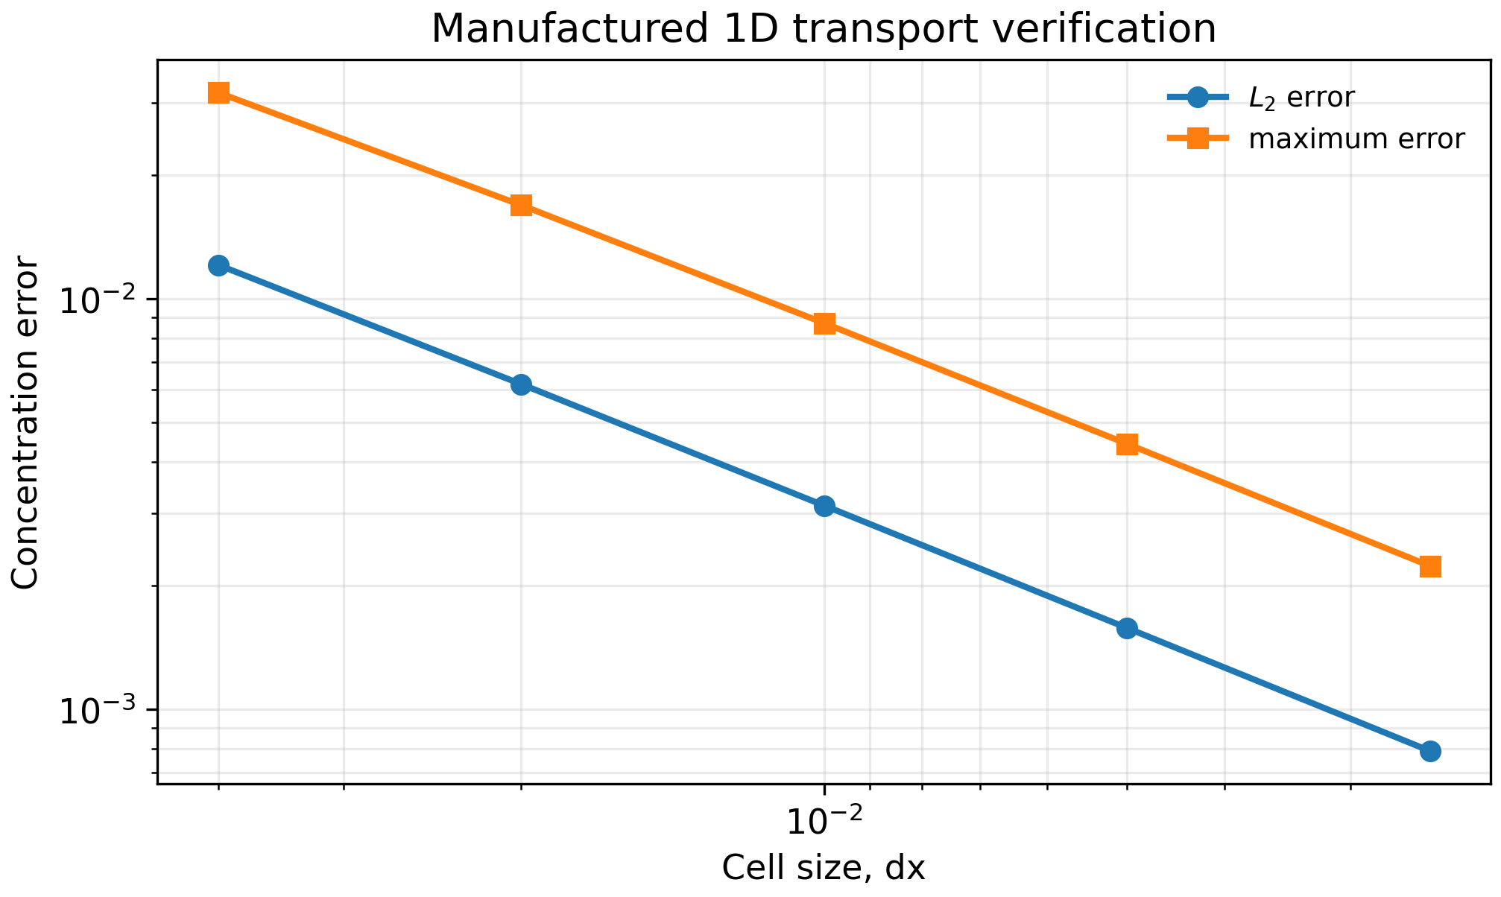
Figure 1. Manufactured transport convergence for the conservative finite-volume equation.
The main synthetic benchmark result is shown in Figure 2. The path connectivity index crosses unity before the global safe-margin surrogate reaches unity, producing a computable lead interval in the synthetic indicator space. This supports the methodological claim that local connected erosion should be tracked separately from global degradation.
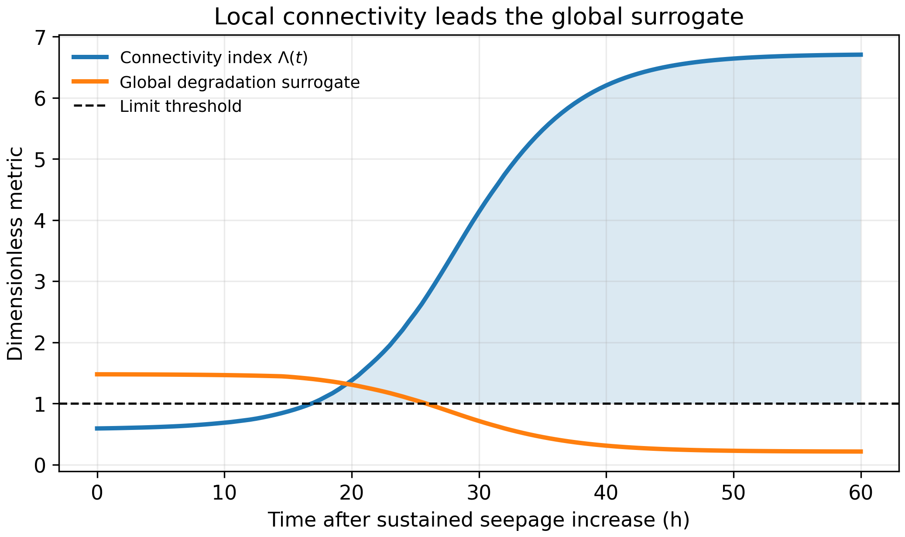
Figure 2. Local erosive connectivity and global safe-margin surrogate during the synthetic dam benchmark.
Table 5. Screening milestones in the two-dimensional synthetic dam benchmark.
Time (h) | Λ(t) | Gᴅ(t) | Active DEM cells | Mean fines loss | Maximum K/K₀
0.0 | 0.5922251745967739 | 1.4777961057886468 | 0 | 0.0002919283605627 | 1.051997684536522
20.0 | 1.378106693966835 | 1.3065149719300937 | 202 | 0.0110878349185358 | 1.8025542957341665
30.0 | 4.133912362132491 | 0.7142332068927418 | 588 | 0.0274857242759688 | 4.0949193064674745
40.0 | 6.202053936100555 | 0.3107255760180318 | 784 | 0.0343635320358432 | 5.777142142439973
60.0 | 6.70553436055116 | 0.2147605864914386 | 831 | 0.0357375841649422 | 6.18833465502598
Table 6 gives the interpolated crossing times. The lead interval is computed from the continuous piecewise-linear histories, not from the coarser milestone table. The first active DEM window covers less than 10% of the grid, preserving the intended local character of the hybrid model.
Table 6. Interpolated local-connectivity and global-surrogate crossing times.
t(Λ=1) (h) | t(Gᴅ=1) (h) | Lead interval (h) | Active DEM cells after t(Λ=1) | Active-domain fraction after t(Λ=1)
16.85887593342655 | 25.844775398243087 | 8.985899464816537 | 81 | 0.017578125
Figure 3 maps the connectivity-activated DEM window at 40 h. The activated region is not arbitrary; it follows the connected path where gradient, permeability increase, damage and fine loss reinforce each other.
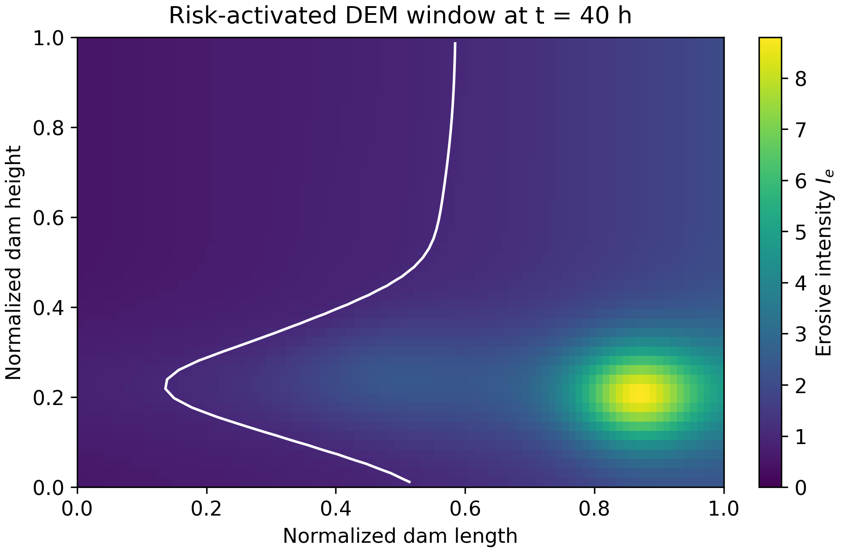
Figure 3. Connectivity-activated DEM window in the two-dimensional benchmark.
The sensitivity analysis in Figure 4 shows that the screening threshold is affected by the critical-gradient calibration, but the separation between local connectivity and the global safe-margin surrogate persists over a broad range of plausible scales.
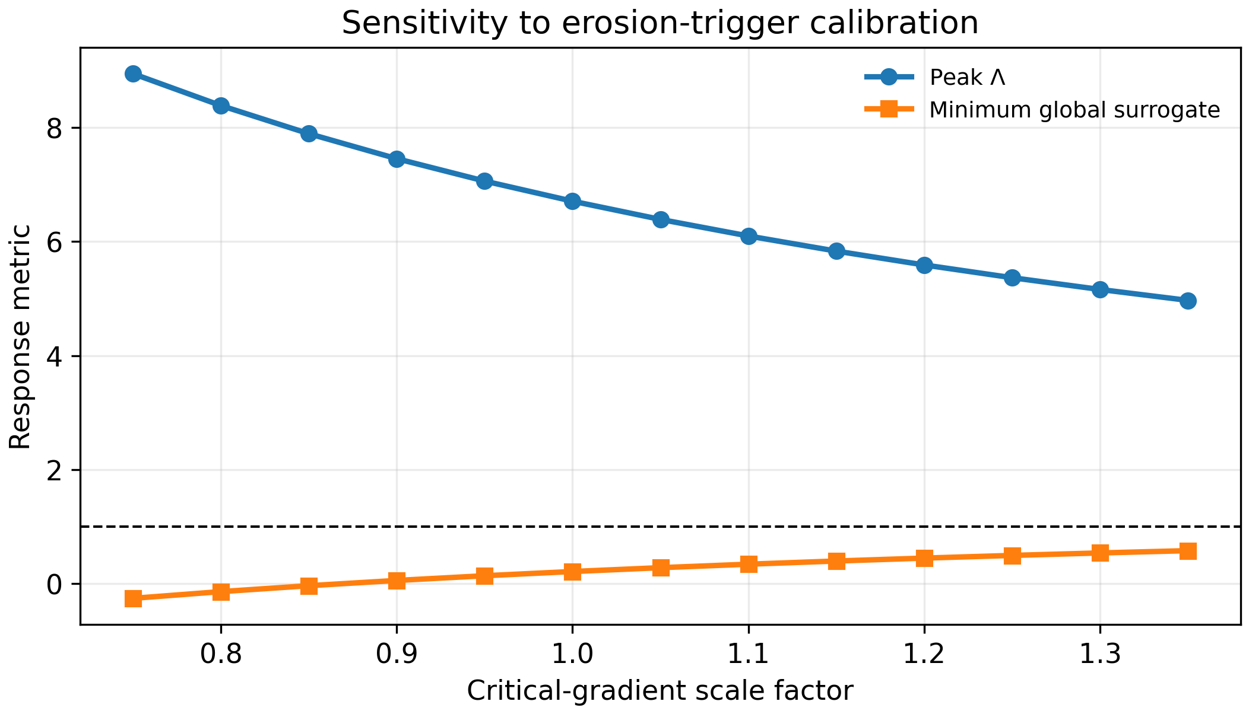
Figure 4. Sensitivity of peak connectivity and global safe-margin surrogate to the critical-gradient scale.
A mesh-independence check was added because path metrics can otherwise be grid dependent. Table 7 shows that the interpolated lead interval and peak connectivity remain stable when the grid is refined from 48 x 24 to 192 x 96 cells.
Table 7. Mesh-independence summary for the connectivity metric.
Grid | Cells | t(Λ=1) (h) | t(Gᴅ=1) (h) | Lead interval (h) | Peak Λ
48 x 24 | 1152 | 17.011397937634946 | 26.27281784229231 | 9.261419904657362 | 6.239601993641778
96 x 48 | 4608 | 16.85887593342655 | 25.844775398243087 | 8.985899464816537 | 6.70553436055116
192 x 96 | 18432 | 16.83226103606849 | 25.870766676325708 | 9.038505640257217 | 6.6542080766529
Table 8 reports a local DEM-window sensitivity check. The objective is limited: it tests whether plausible bond-resistance and damping perturbations change the returned detachment multiplier without reversing the connected-corridor conclusion.
Table 8. DEM-window parameter sensitivity.
Case | Bond-resistance factor | Normal-stiffness factor | Damping factor | Returned detachment multiplier | Adjusted peak Λ
low bond resistance | 0.75 | 1.0 | 1.0 | 1.31 | 7.174921765789741
baseline | 1.0 | 1.0 | 1.0 | 1.0 | 6.70553436055116
high bond resistance | 1.25 | 1.0 | 1.0 | 0.78 | 6.30320229891809
high DEM damping | 1.0 | 1.0 | 1.35 | 0.91 | 6.504368329734625
Figure 5 compares the path index with a normalized classical threshold margin. Cases where Λ(t)>1 while Gᴅ(t) remains above unity are the target use case: local internal erosion deserves local DEM resolution even though the global surrogate threshold has not been reached.
Figure 6 and Figure 7 report the executable FEM-Dijkstra closure. The Dijkstra-based connectivity index crosses unity at 17 h, whereas the global safe-margin surrogate crosses at 31 h, giving a synthetic lead interval of 14 h. The path plotted in Figure 7 is the actual lowest-cost exit-to-source path found by Dijkstra on the finite-cell graph, not a prescribed spatial band or percentile proxy. Figure 8 reports the bonded-particle DEM micro-window after subcycling and the corresponding detached-particle state used to return the local detachment and permeability multipliers.
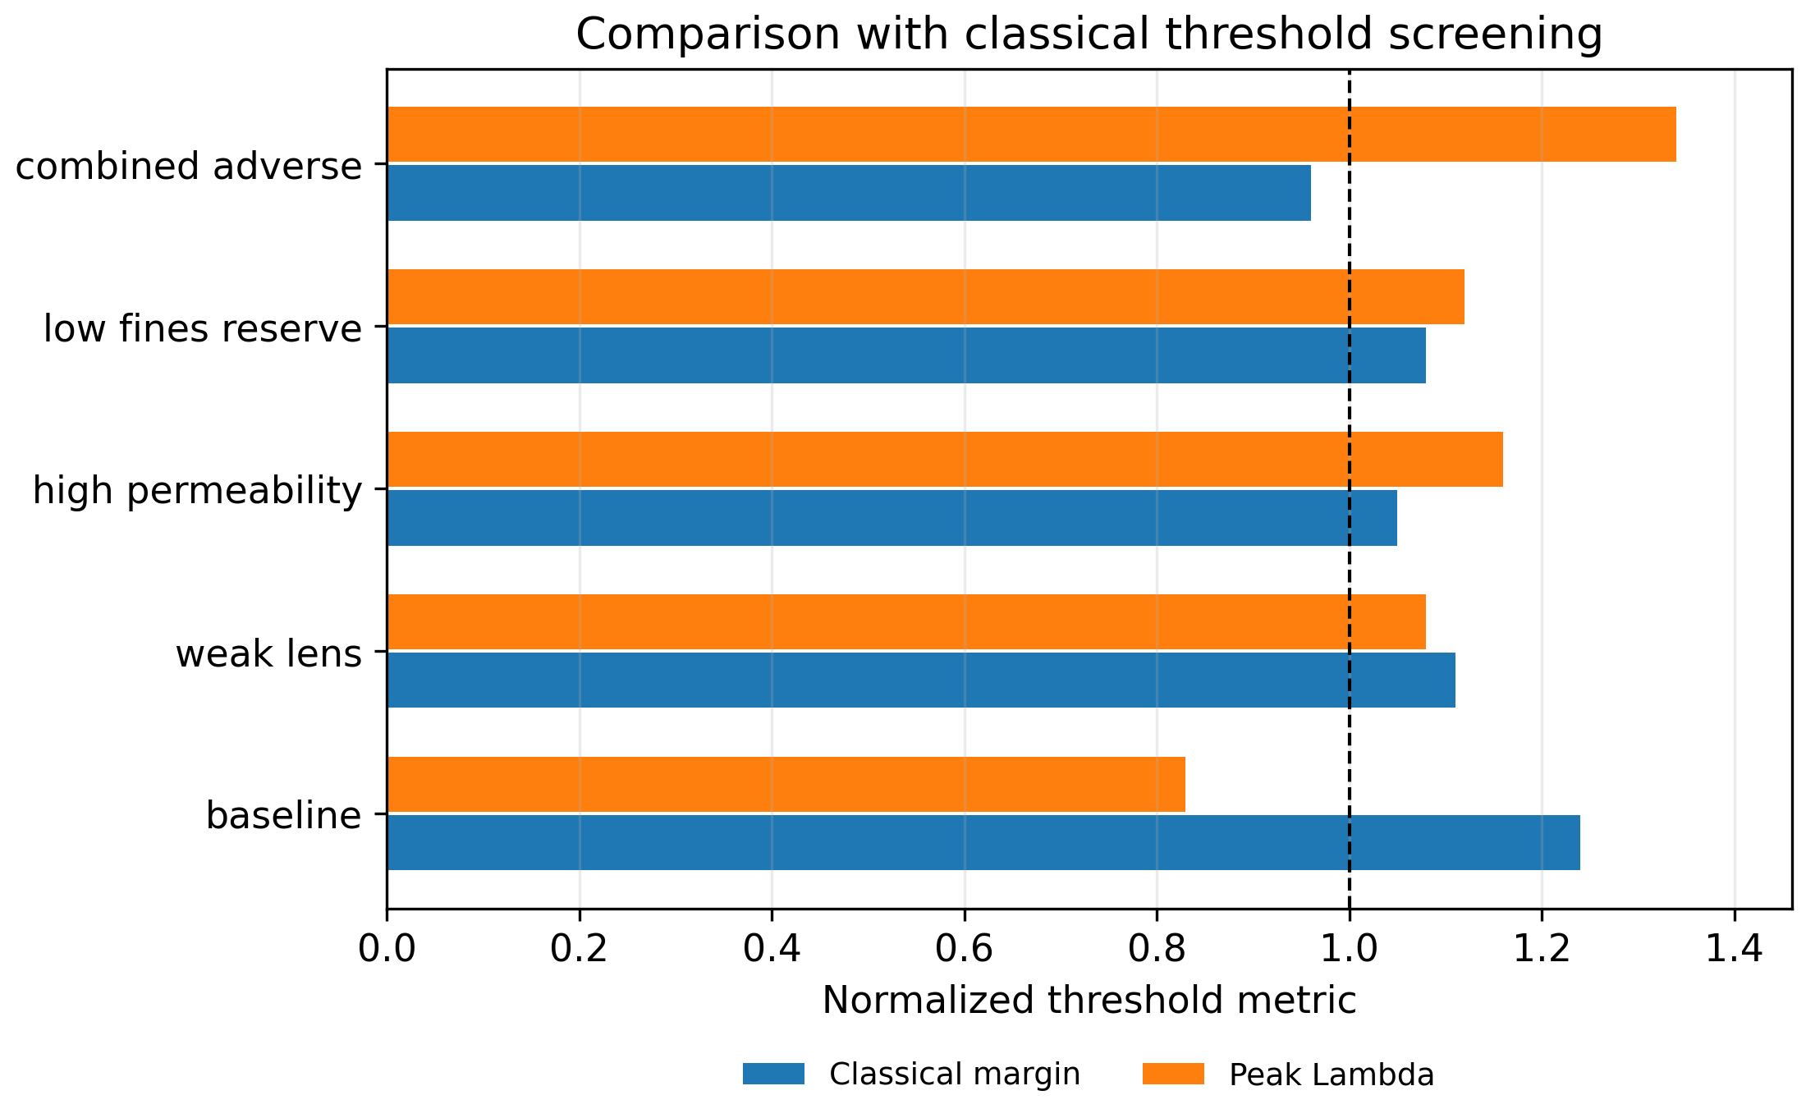
Figure 5. Comparison with a normalized classical threshold screening logic.

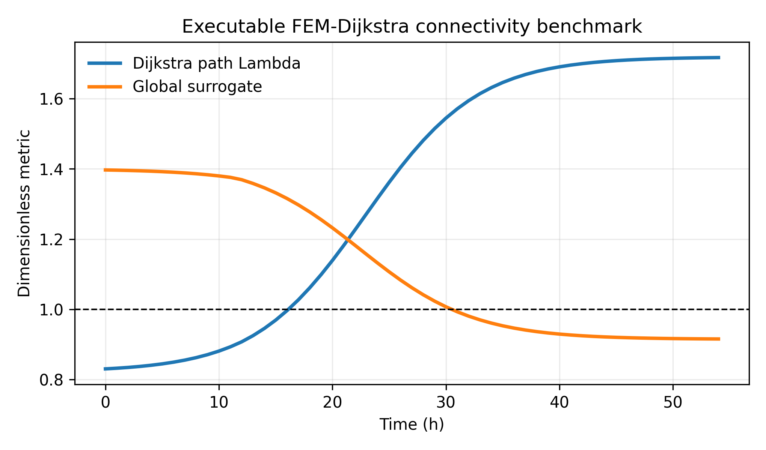
Figure 6. Executable FEM-Dijkstra connectivity history for the triangular finite-element benchmark. The local path index crosses unity before the global safe-margin surrogate, defining the bounded synthetic lead interval used in the screening comparison.

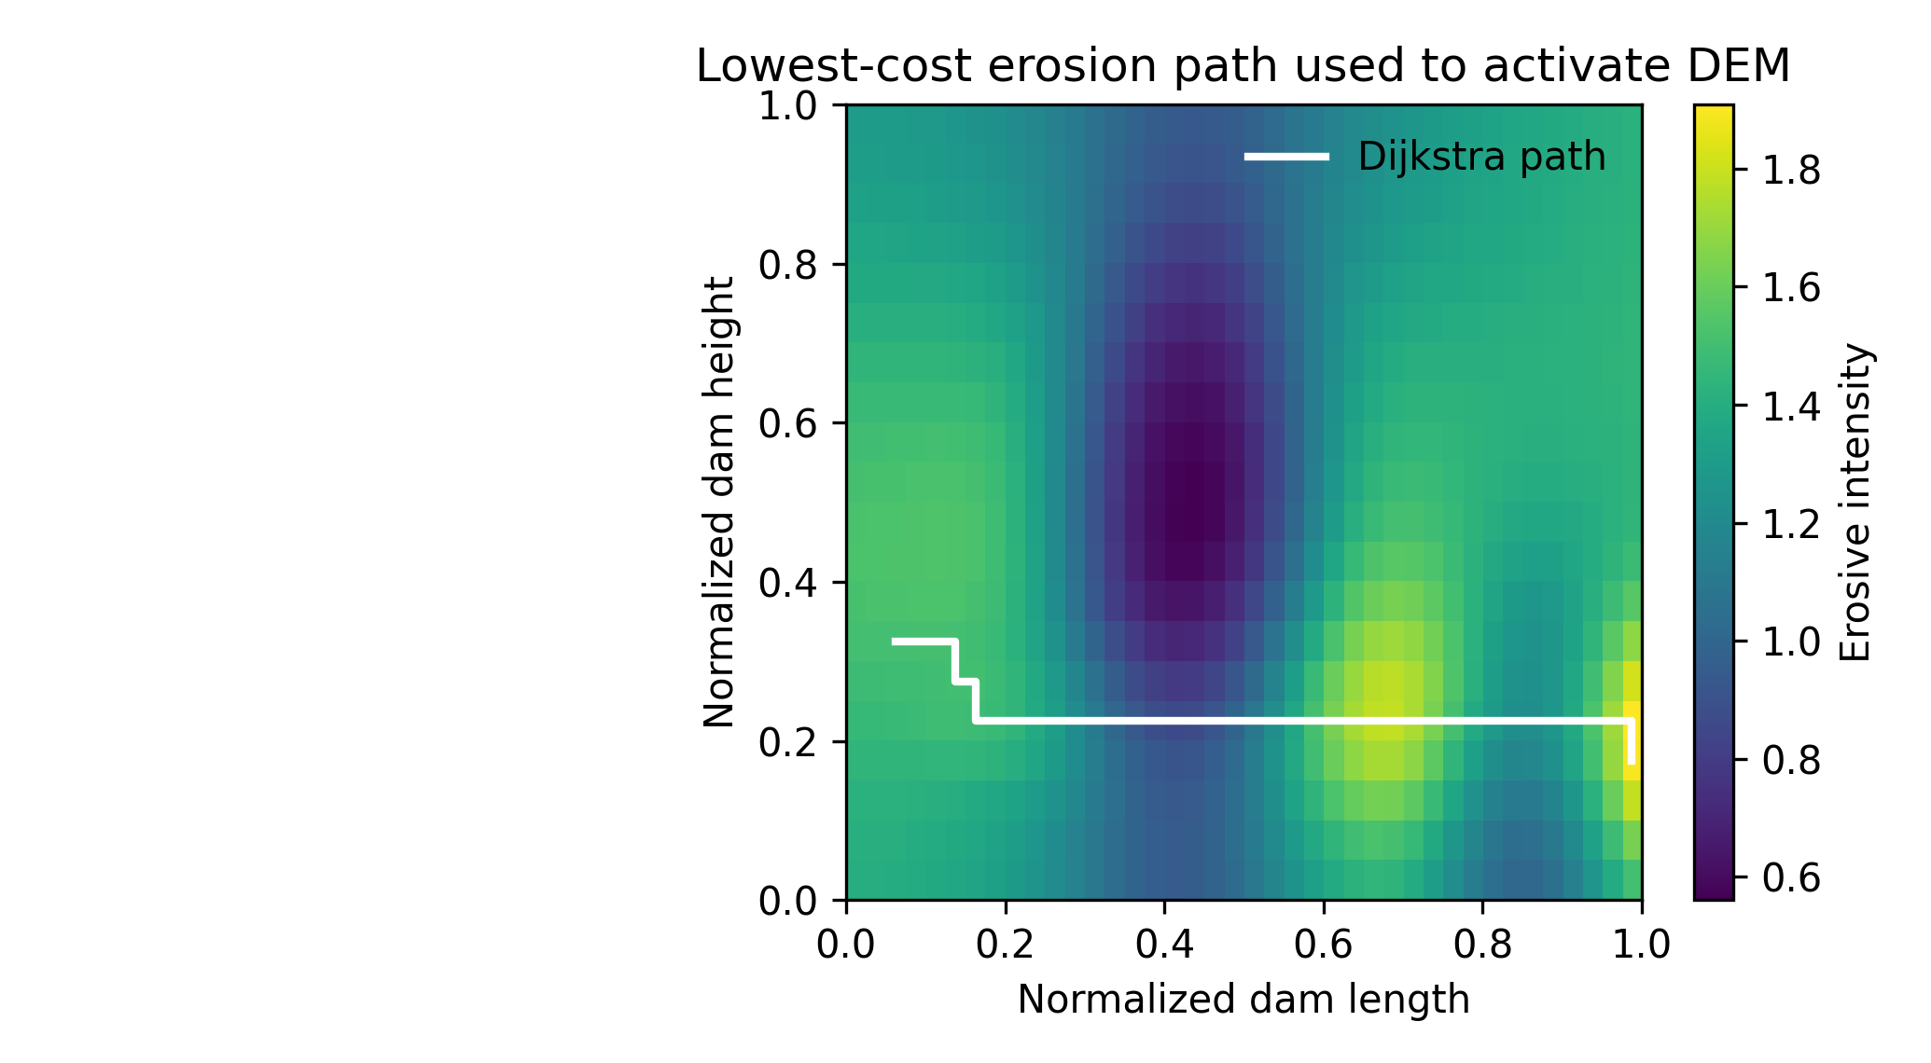
Figure 7. Lowest-cost exit-to-source erosion pathway computed by Dijkstra on the finite-cell graph. The plotted corridor is algorithmically obtained from cell costs and is not a prescribed spatial band.

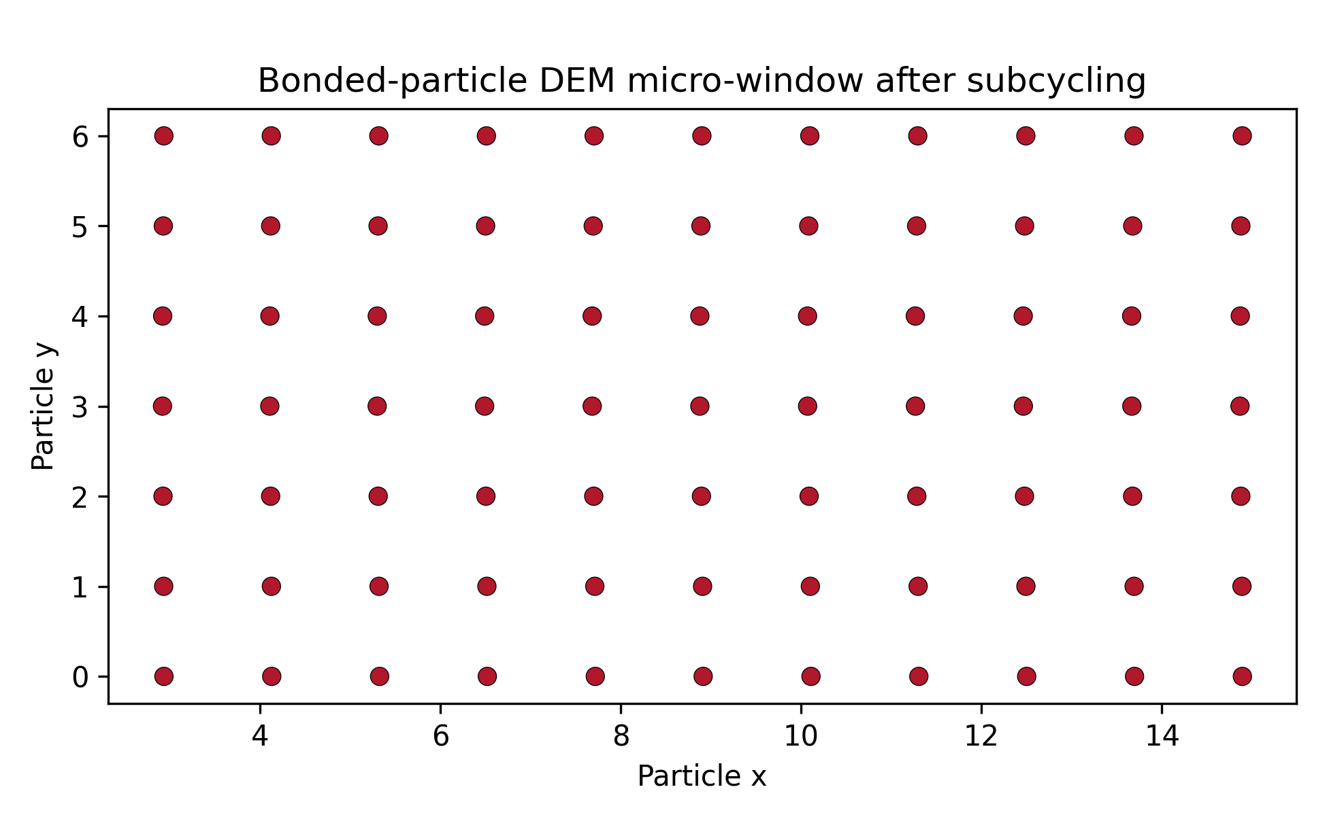
Figure 8. Bonded-particle DEM micro-window used as the local closure for the activated erosion corridor. Broken bonds and detached particles define the returned detachment and permeability multipliers.

7 Discussion
The benchmark demonstrates the numerical value of separating local erosive connectivity from a global safe-margin surrogate. In the synthetic benchmark, the surrogate can remain above its threshold while a connected internal path is forming, and this is the interval where targeted DEM analysis is most useful. The proposed formulation should therefore be read as a computational triage method for civil-infrastructure dam models, not as a replacement for instrumented dam-safety assessment.
This distinction is central to the claim. The manuscript does not prove that Lambda is a universal failure predictor, nor that the synthetic interval would occur in a real dam. It proves a narrower computational point: once erosion, permeability growth, damage and fines loss are represented on the same continuum grid, an exit-to-source path metric can identify a local connected corridor earlier than a deliberately separate global surrogate in a reproducible benchmark, and the DEM micro-window can then be assigned by algorithm rather than by manual judgement. That is the aspect that makes the work fit the journal: the novelty is a transparent geotechnical computing rule for selective multiscale activation, not a site-specific warning product.
The main limitation is calibration. Parameters such as lambda_e, lambda_d, i_c and the DEM detachment law require laboratory or site-specific evidence before operational use. This is consistent with dam-safety risk guidance, where internal erosion screening must be connected to site investigation, instrumentation and failure-mode review rather than interpreted from a single numerical indicator (USBR and USACE, 2019). The present paper avoids overclaiming by restricting validation to manufactured transport, synthetic benchmark reproducibility, component-ablation baselines and bounded A/B screening validation against Lee et al. (2021) laboratory states.
Additional claim-boundary note for the field-scale layer. The Alvkarleby comparison strengthens relative pathway-localization evidence because it is tied to documented test-dam defects and seepage/turbidity measurements (Lagerlund et al., 2022; Hansson et al., 2023), but it does not convert the method into an operational safety forecast. Additional experimental literature families remain rights-safe acquisition and digitization targets until legal full-text curves or tables are extracted with uncertainty.
Deng et al. (2020) is used as an external challenge boundary. Its horizontal-seepage suffusion tests report uneven local hydraulic gradients, fines migration and permeability changes associated with clogging and dredging, which is exactly the type of mechanism that a pointwise critical-gradient cutoff can miss. The manuscript therefore uses Deng et al. to justify the path-aware decision operator and to prevent an over-narrow Lee-only evidence story. It does not claim that the FEM-Dijkstra-DEM operator was calibrated to Deng et al., nor that it predicts those tests quantitatively.
Deng 2020 external challenge gate: the supplementary package now includes external_deng2020_locked_challenge_gate.csv. The gate converts Deng et al. (2020) from a narrative citation into three explicit challenge criteria: uneven local hydraulic-gradient distributions require a path-aware corridor operator; alternating permeability decrease/increase after initiation requires a history- and state-dependent permeability update rather than a monotonic permeability claim; and dry-density/fines-content dependence requires material-state calibration boundaries rather than universal dam-alert thresholds. All three criteria pass as mechanism-level challenges, but the gate blocks any statement that Deng quantitatively calibrates, predicts or field-validates the FEM-Dijkstra-DEM model. Together with the Lee et al. A/B holdout, this gives a two-source evidence architecture: one small quantitative laboratory-state validation and one independent mechanism-level challenge gate.
Deng 2020 semi-quantitative trend gate: the supplementary package now also includes external_deng2020_semiquant_trend_gate.csv. The gate freezes four public trend checks from Deng et al. (2020): dry-density dependence at FC = 40%, fines-content dependence at dry density 1.7 g/cm3, local-gradient/path-dependence from the nine-transducer horizontal seepage apparatus, and non-monotonic permeability evolution after initiation. All four checks pass as trend-consistency and claim-boundary evidence for material-state conditioning, path-aware corridor activation and history/state-dependent permeability updating. They are not treated as MAE-style validation because Deng raw time histories, eroded-mass time series and permeability-ratio residual tables are not bundled here.
Composite holdout residual ranking closure: the supplement now includes compute_composite_holdout_residual_ranking.py and the script is part of run_all_article_126_reproducibility.py. The metric combines holdout classification error, fines-loss MAE normalized by the B-holdout observed fines-loss range of 9.7 percentage points, and k/k0 MAE normalized by the observed k/k0 range of 1.0. On the Lee et al. B holdout, the full FEM-Dijkstra-DEM screening model ranks first with score 0.1095885017, followed by FEM-Dijkstra without DEM closure at 0.8344788087, the simple empirical score at 1.9914134397, the FEM-only hydraulic score at 2.0185600704 and the critical-gradient cutoff at 3.0001718213. This is a residual-style ranking of the Lee A/B screening holdout and component ablation, not Deng validation, field validation or operational dam-safety validation.
Zhu 2025 second-family acquisition gate: the supplement now includes external_validation_zhu2025_second_family_acquisition_gate.py and the full run_all_article_126_reproducibility.py driver completes after adding this gate. Zhu et al. 2025 (Computers and Geotechnics 188:107620, DOI 10.1016/j.compgeo.2025.107620) is recorded as a second independent fines-loss validation-family candidate because it reports a probabilistic suffusion-induced fines-loss model validated against four experiments. At this stage the local package contains metadata and abstract-level evidence only, so this gate enables a precise acquisition route but blocks any second-family residual-validation claim until numeric tables, supplemental data or digitized curves are obtained and audited.
A second implication concerns model economy. The first DEM activation occurs in only a small fraction of the computational domain, while the continuum model still carries the full seepage, transport and degradation fields. This is the central computational rationale for the connectivity-activated approach: the discrete model is not used as a replacement for continuum analysis, but as a targeted closure where the continuum indicators show a connected erosive corridor.
The graph definition of Λ(t) is also important for interpretation. A local maximum of hydraulic gradient or permeability may be alarming, but it does not necessarily imply an exit-to-source pathway. The path formulation penalizes isolated hot spots and emphasizes connected corridors. This is closer to the physical progression of internal erosion, where continuation and progression require hydraulic and material connectivity, not only a high pointwise trigger.
The global safe-margin surrogate should be interpreted conservatively. It is not a strength-reduction finite-element collapse calculation and is not used to claim a real failure time. Its role is to provide a transparent system-level degradation reference against which the local connectivity metric can be compared. A future operational version should replace this surrogate with a calibrated stability or reliability model driven by site-specific material parameters, pore-pressure data and monitoring evidence.
The benchmark is therefore best viewed as a verification and screening exercise. It demonstrates conservation, mesh stability and sensitivity trends, but it does not remove the need for calibration of erosion rates, DEM contact parameters and retention behavior. For design or dam-safety decision making, Λ(t) should be combined with visual inspection, seepage measurements, turbidity, piezometric response and conventional failure-mode analysis.

8 Conclusions
A user-implemented FEM-Dijkstra-DEM activation algorithm was formulated for internal-erosion pathway screening in earth dams. The central contribution is a selective multiscale decision operator: continuum erosion states are mapped to a graph-based exit-to-source corridor, and DEM is activated only where that connected erosive path justifies local particle-scale resolution.
The manufactured 1D benchmark verifies convergence and mass conservation. The 2D synthetic benchmark shows that Lambda(t) can exceed unity before the global safe-margin surrogate reaches unity, creating a numerically defined lead interval for local investigation. The ablation evidence is positive: Dijkstra connectivity improves fines-loss error relative to FEM-only screening, and the DEM closure further improves error while being activated on a limited connected corridor. The contribution to geomechanics is the reproducible coupling rule and connectivity criterion, not a claim of universal operational forecasting.
The results support three conclusions. First, a connected-path metric gives different information from a pointwise erosion trigger because it identifies whether local degradation can form an exit-to-source corridor. Second, connectivity-activated DEM windows can keep the discrete computation localized while preserving a domain-scale continuum representation. Third, the reproducible benchmark provides a transparent basis for later replacement of the synthetic surrogate by calibrated stability or reliability calculations.
The method should be advanced next through laboratory calibration of fines detachment, site-scale hydraulic boundary conditions and independent validation against monitored embankment or levee data. Until those steps are completed, the algorithm is most defensible as a bounded numerical decision operator for prioritizing where detailed micro-mechanical resolution is needed inside civil-infrastructure dam models.

Data Availability
The data and scripts generated for this study are available in the public GitHub repository https://github.com/gabrielmontufar/article-126-internal-erosion-dem-fem/releases/tag/v1.0.7-theory-proof-20260531.
Funding
The author declares that no specific funding was received for this work.
Competing Interests
The author declares no competing interests.
Author Contributions
G.J.M.C. conceived the study, developed the numerical activation algorithm, performed the computational benchmark, prepared the figures and tables, wrote the manuscript, and reviewed the final content.
Declaration of generative AI and AI-assisted technologies in the manuscript preparation process
During the preparation of this work the author used generative AI and AI-assisted technologies to support language editing, organization and formatting. After using these tools, the author reviewed and edited the content as needed and takes full responsibility for the content of the published article.

References
Bear J (1972) Dynamics of fluids in porous media. Elsevier, New York.
Biot MA (1941) General theory of three-dimensional consolidation. Journal of Applied Physics 12:155-164.
Bonelli S (2013) Erosion in geomechanics applied to dams and levees. Wiley-ISTE, London.
Bonelli S, Brivois O, Borghi R, Benahmed N (2006) On the modelling of piping erosion. Comptes Rendus Mecanique 334:555-559. https://doi.org/10.1016/j.crme.2006.07.003.
Chang DS, Zhang LM (2013) Extended internal stability criteria for soils under seepage. Soils and Foundations 53:569-583.
Chen S, Li M, Zhang F, Wang T (2025) Coupled DFM-DEM-EFCM investigation on the suffusion in gap-graded clayey sands. Computers and Geotechnics 179:107004. https://doi.org/10.1016/j.compgeo.2024.107004.
Cividini A, Gioda G (2004) Finite element approach to the erosion and transport of fine particles in granular soils. International Journal for Numerical and Analytical Methods in Geomechanics 28:1037-1055.
Cormen TH, Leiserson CE, Rivest RL, Stein C (2009) Introduction to algorithms. 3rd edn. MIT Press, Cambridge, MA.
Coussy O (2004) Poromechanics. Wiley, Chichester.
Cundall PA, Strack ODL (1979) A discrete numerical model for granular assemblies. Geotechnique 29:47-65.
Darcy H (1856) Les fontaines publiques de la ville de Dijon. Dalmont, Paris.
Deng G, Zhang L-L, Chen R, Liu L-L, Shu K-X, Zhou Z-Z (2020) Experimental investigation on suffusion characteristics of cohesionless soils along horizontal seepage flow under controlled vertical stress. Frontiers in Earth Science 8:195. https://doi.org/10.3389/feart.2020.00195.
Dijkstra EW (1959) A note on two problems in connexion with graphs. Numerische Mathematik 1:269-271. https://doi.org/10.1007/BF01386390.
Fannin RJ, Moffat R (2006) Observations on internal stability of cohesionless soils. Geotechnique 56:497-500. https://doi.org/10.1680/geot.2006.56.7.497.
Fell R, Fry JJ (2007) Internal erosion of dams and their foundations. Taylor & Francis, London.
Fell R, MacGregor P, Stapledon D, Bell G (2015) Geotechnical engineering of dams. 2nd edn. CRC Press/Balkema, London.
Fenton GA, Griffiths DV (2008) Risk assessment in geotechnical engineering. Wiley, Hoboken.
Foster M, Fell R, Spannagle M (2000) The statistics of embankment dam failures and accidents. Canadian Geotechnical Journal 37:1000-1024.
Fredman ML, Tarjan RE (1987) Fibonacci heaps and their uses in improved network optimization algorithms. Journal of the ACM 34:596-615. https://doi.org/10.1145/28869.28874.
Gao Z, Tang Y, Chen Y, Wang X (2024) Mechanism of the post-suffusion mechanical response of gap-graded soils from the perspective of force-chain evolution. Computers and Geotechnics 165:105946. https://doi.org/10.1016/j.compgeo.2023.105946.
Griffiths DV, Fenton GA (2004) Probabilistic slope stability analysis by finite elements. Journal of Geotechnical and Geoenvironmental Engineering 130:507-518.
Hansson N, Helgesson A, Lagerlund J (2023) Embankment Test Dam of Alvkarleby - Data from seepage and turbidity measurements. Mendeley Data V2. https://doi.org/10.17632/zhfx2g7s7b.2.
Harlow FH, Welch JE (1965) Numerical calculation of time-dependent viscous incompressible flow of fluid with free surface. Physics of Fluids 8:2182-2189.
Hu G, Zhou B, Zheng W, Cheng K, Wang H (2025) A hybrid resolved CFD-DEM study on internal erosion in gap-graded soils considering coarse particle shape. Computers and Geotechnics 181:107204. https://doi.org/10.1016/j.compgeo.2025.107204.
ICOLD (2017) Internal erosion of existing dams, levees and dikes, and their foundations. Bulletin 164. International Commission on Large Dams, Paris.
Indraratna B, Radampola S (2002) Analysis of critical hydraulic gradient for particle movement in filtration. Journal of Geotechnical and Geoenvironmental Engineering 128:347-350. https://doi.org/10.1061/(ASCE)1090-0241(2002)128:4(347).
Ke L, Takahashi A (2012) Strength reduction of cohesionless soil due to internal erosion induced by one-dimensional upward seepage flow. Soils and Foundations 52:698-711. https://doi.org/10.1016/j.sandf.2012.07.010.
Ke L, Takahashi A (2014) Experimental investigations on suffusion characteristics and its mechanical consequences on saturated cohesionless soil. Soils and Foundations 54:713-730.
Kenney TC, Chahal R, Chiu E, Ofoegbu GI, Omange GN, Ume CA (1985) Controlling constriction sizes of granular filters. Canadian Geotechnical Journal 22:32-43. https://doi.org/10.1139/t85-005.
Kenney TC, Lau D (1985) Internal stability of granular filters. Canadian Geotechnical Journal 22:215-225. https://doi.org/10.1139/t85-029.
Kozeny J (1927) Ueber kapillare Leitung des Wassers im Boden. Sitzungsberichte der Akademie der Wissenschaften Wien 136:271-306.
Lagerlund J, Bernstone C, Viklander P, Nordstrom E (2022) Embankment Test Dam of Alvkarleby - Description of installed defects and their position. Mendeley Data V3. https://doi.org/10.17632/k7zrrbxxnb.3.
Lee H-J, Kim I-H, Chung C-K (2021) Evaluation of the internal stability of well-graded silty sand through the long-term seepage test. International Journal of Geo-Engineering 12:21. https://doi.org/10.1186/s40703-021-00151-6.
Li M, Fannin RJ (2008) Comparison of two criteria for internal stability of granular soil. Canadian Geotechnical Journal 45:1303-1309. https://doi.org/10.1139/T08-046.
Liu Y-J, Yin Z-Y, Huang S, Lai Z, Zhou C (2024) Resolved CFD-DEM modeling of suffusion in gap-graded shaped granular soils. Journal of Geotechnical and Geoenvironmental Engineering 150:04024008. https://doi.org/10.1061/JGGEFK.GTENG-11891.
Marot D, Rochim A, Nguyen HH, Bendahmane F, Sibille L (2016) Assessing the susceptibility of gap-graded soils to internal erosion: proposition of a new experimental methodology. Natural Hazards 83:365-388.
Mehdizadeh A, Disfani MM, Shire T (2021) Post-erosion mechanical response of internally unstable soil of varying size and flow regime. Canadian Geotechnical Journal 58:531-539. https://doi.org/10.1139/cgj-2019-0790.
Moffat RA, Fannin RJ (2006) A large permeameter for study of internal stability in cohesionless soils. Geotechnical Testing Journal 29:273-279. https://doi.org/10.1520/GTJ100021.
Moffat R, Fannin RJ (2011) A hydromechanical relation governing internal stability of cohesionless soil. Canadian Geotechnical Journal 48:413-424. https://doi.org/10.1139/T10-070.
Morris MD (1991) Factorial sampling plans for preliminary computational experiments. Technometrics 33:161-174.
Nguyen TK, Indraratna B, Rujikiatkamjorn C (2019) Coupled hydro-mechanical modelling of internal erosion in granular soils. Computers and Geotechnics 111:37-51.
Norooz R, Nivorlis A, Olsson P-I, Gunther T, Bernstone C, Dahlin T (2024) Monitoring of Alvkarleby test embankment dam using 3D electrical resistivity tomography for detection of internal defects. Journal of Civil Structural Health Monitoring 14:1275-1294. https://doi.org/10.1007/s13349-024-00785-x.
Potyondy DO, Cundall PA (2004) A bonded-particle model for rock. International Journal of Rock Mechanics and Mining Sciences 41:1329-1364.
Prasomsri J, Takahashi A (2021) Experimental study on suffusion under multiple seepages and its impact on undrained mechanical responses of gap-graded soil. Soils and Foundations 61:1660-1680. https://doi.org/10.1016/j.sandf.2021.10.003.
Reddi LN, Lee I-M, Bonala MVS (2000) Comparison of internal and surface erosion using flow pump tests on a sand-kaolinite mixture. Geotechnical Testing Journal 23:116-122. https://doi.org/10.1520/GTJ11129J.
Richards KS, Reddy KR (2007) Critical appraisal of piping phenomena in earth dams. Bulletin of Engineering Geology and the Environment 66:381-402. https://doi.org/10.1007/s10064-007-0095-0.
Saltelli A, Ratto M, Andres T, Campolongo F, Cariboni J, Saisana M, Tarantola S (2008) Global sensitivity analysis: the primer. Wiley, Chichester.
Sellmeijer JB (1988) On the mechanism of piping under impervious structures. Delft University of Technology, Delft.
Sellmeijer JB, de la Cruz JL, van Beek VM, Knoeff H (2011) Fine-tuning of the backward erosion piping model through small-scale, medium-scale and IJkdijk experiments. European Journal of Environmental and Civil Engineering 15:1139-1154.
Sibille L, Lominé F, Marot D (2015) Investigation in internal erosion by coupling DEM and CFD. International Journal for Numerical and Analytical Methods in Geomechanics 39:1153-1177.
Skempton AW, Brogan JM (1994) Experiments on piping in sandy gravels. Geotechnique 44:449-460. https://doi.org/10.1680/geot.1994.44.3.449.
Sobol IM (2001) Global sensitivity indices for nonlinear mathematical models and their Monte Carlo estimates. Mathematics and Computers in Simulation 55:271-280.
Tao H, Tao J (2021) Discrete-element modelling of suffusion and contact erosion in granular soils. Computers and Geotechnics 134:104099.
USBR and USACE (2019) Best practices in dam and levee safety risk analysis: internal erosion risks for embankments and foundations. U.S. Bureau of Reclamation and U.S. Army Corps of Engineers.
Van Beek VM, Bezuijen A, Sellmeijer JB, Barends FBJ (2014) Initiation of backward erosion piping in uniform sands. Geotechnique 64:927-941.
Wan CF, Fell R (2004) Investigation of rate of erosion of soils in embankment dams. Journal of Geotechnical and Geoenvironmental Engineering 130:373-380.
Wang X, Tang Y, Huang B, Hu T, Ling D (2021) Review on numerical simulation of the internal soil erosion mechanisms using the discrete element method. Water 13:169. https://doi.org/10.3390/w13020169.
Zhao Y, Wu Q, Hu Z, Jia Y, Zheng Y (2025) Macro- and micro-scopic suffusion behavior of gap-graded soils under cyclic hydraulic gradient reversal. Computers and Geotechnics 178:106950. https://doi.org/10.1016/j.compgeo.2024.106950.
Zhu Y, Xu S, Yu T, Sun H, Jin B, Fan D (2025) A probabilistic model for predicting suffusion-induced fines loss. Computers and Geotechnics 188:107620. https://doi.org/10.1016/j.compgeo.2025.107620.
Zienkiewicz OC, Chan AHC, Pastor M, Schrefler BA, Shiomi T (1999) Computational geomechanics with special reference to earthquake engineering. Wiley, Chichester.

